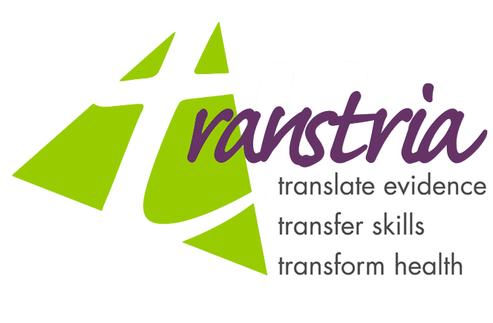
Contact: Laura K. Brennan Ramirez of Transtria – 314.781.1562
Re: Formation of woman-owned public health research and consulting enterprise
September 1, 2005
Immediate Release

Fresh on the Market: Transtria L.L.C., Public Health Research and
Consulting Services

Transtria L.L.C, a woman-owned enterprise, was created under the leadership of Dr. Laura Brennan Ramirez to sustain the quality services provided by partners and staff of Inneval, LLC (recently dissolved through mutual consent of its founders). All of the full- and part-time staff have accepted positions at Transtria L.L.C during the transition, and as a result, the project teams and services have remained intact.
Transtria is a public health research and consulting company with a vision of uniting people, places and policies to revolutionize public health. Its mission is to translate evidence to enhance public health decision-making; transfer skills to sustain public health research and practice efforts; and transform health through policy, environmental, economic and social change. By providing leadership and technical assistance to support the development, implementation, and evaluation of research and practice-based initiatives, Transtria works with clients and community partners to understand their needs, create a collaborative process for engagement, identify strategies for change, and monitor progress.
Collectively, Inneval and Transtria have served a client base of state and federal government agencies, foundations, universities, and community-based organizations for over five years. The company continues to build partnerships and conduct projects to improve public health.
###

